Typical inquiry form: Mirrors for GRAZING optical schemes
STEP ONE: fill green cells and check PURPOSE of required mirror. (Appendix 1)
CREATE of IMAGE of the source ("point to point focusing")  (focal spot Ø ~ 1-300 micrometer) |  |  | Beam ENERGY CHANNELING without high-quality image  (focal spot Ø ~ 0.3-3 millimeter)
STEP TWO: fix FIVE parameters (green cells). (Appendix 2)
A). Choose a compromise between Angle Of Incidence and Length of Clear Aperture (Tangential plane) (Appendix 3)
Angle Of Incidence (AOI) or Grazing Angle (Ɵ = 90⁰-AOI) |  | [degrees] |  | Enter value here
Clear Aperture Length and Width (Drawing below) |  | [mm] +0.5, -0.0 |  | Enter value here
B). Choose Distance to source (S) and Distance to Image (S’) considering the size of used vacuum chamber, optical setup scheme and etc.
Distance to source/input arm, S (Drawing below) |  | [mm] ±0.5% |  | Enter value here (infinite for collimated beam)
Distance to image/exit arm, S’ (Drawing below) |  | [mm] ±0.5% |  | Enter value here (infinite for collimated beam)
C). Choose Desirable Focal Spot Diameter (less value – higher accuracy necessary – higher price). (Appendix 1)
Focal Spot Diameter for IMAGE purpose, FWHM unless otherwise agreed |  | [micro-meter, µm] |  | Enter value here
STEP THREE: fix other work parameters (green cells)
Working Spectral Range |  | [nm] |  | Enter value here
Desirable reflectivity (average unless otherwise agreed) or Metal |  | [%] |  | Enter value here
Mirror Dimensions: (Length xWidth) xHeight (±0.5) (Drawing below) |  | [mm] -0.5, +0.0 |  | Enter value here
*) Surface shape tolerance, wave front error λ/N @633nm |  | [1/N] RMS |  | Fill if the absence of wavefront distortion  is very important for your task
Slope Error measured on the mirror, RMS: |  | [arcSec] on Tang- Sag |  | Fill if You want
Surface cosmetic quality, Roughness  (for Visible spectral ranges: surface finish by [Scratches / Digs] |  | [nm] RMS |  | Fill for best quotation
Operating conditions (vacuum degree, baking temperature); Marking & other) |  | Fill for best quotation
Beam Parameters (power & energy load, Pulse parameters). Optical task. Holder. |  | Fill for best quotation

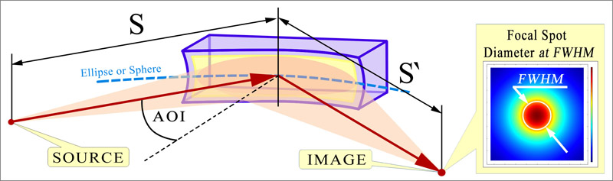 | 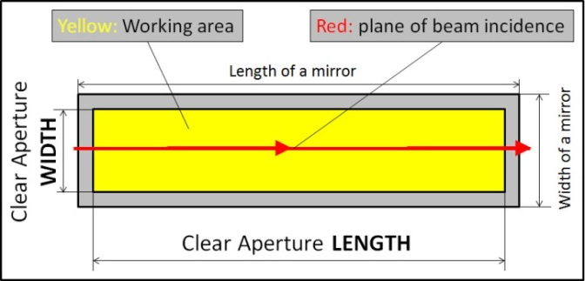
*) The customer can specify the shape tolerance independently by wavefront error (λ/N) or slope error ([arcSec]): both on RMS or PV;
for such order, we can not allways guarantee the expected diameter of the focal spot.

